Webb, John (notes mainly from CALM News 1986)
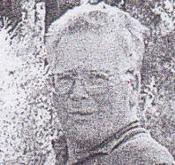
Born 1944 in UK, he joined the Forest Department in 1969. Initially based in Tone River and Wheatley, on wages. Joined Manjimup Working Plans Office in 1974. Worked for WPO/Inventory and Planning for 32 years. Involved in forest inventories and aerial photo duties. Involved in Army Reserve, SES, pistol club, Scouts. Died 2006.

